

TASCO Motor Insurance Growth Platform · TGP-QA-01
Test Strategy
Date – 07 October 2026
Version – 1.0
Prepared by – iorta TechNXT
TABLE OF CONTENTS
1. Document Control 3
2. Acronyms 3
3. Introduction 5
3.1. Sandbox and production 5
4. Scope 5
4.1. In scope 5
4.2. Out of scope 6
5. Test approach 7
5.1. Unit tests 7
5.2. Integration tests 8
5.3. API and contract tests 8
5.4. Functional acceptance tests 8
5.5. System integration testing 8
5.6. User acceptance testing 9
5.7. Non-functional testing 9
5.8. Security testing 10
5.9. Resilience testing 11
5.10. Accessibility and localisation 11
5.11. Compliance testing 12
5.12. Data quality, reconciliation and migration 12
6. Automation and regression 13
6.1. Automated test layers 13
6.2. CI gates 14
6.3. Regression 14
7. Environments 15
8. Test data management 16
9. Entry and exit criteria 16
10. Defect management 17
10.1. Severity 17
10.2. Workflow 17
11. Metrics 18
12. Roles and responsibilities 19
13. Current results 19
14. Known issues 20
15. Appendix 22
15.1. Fixed known issues 22
16. Sign-Off 23

Document Control

Date | Version | Author & Business Unit Info | Reviewed By & Business Unit Info | Approved By & Business Unit Info | Change History
07/10/2026 | 1.0 | iorta TechNXT  Quality Engineering | TASCO Insurance  IT Quality Assurance | TASCO Insurance  Programme Sponsor | Initial issue for submission

Acronyms

Acronym / Symbol | Definition / Meaning
API | Application Programming Interface
ASVS | Application Security Verification Standard
CI | Continuous Integration
DBA | Database Administrator
DNC | Do Not Contact
DR | Disaster Recovery
DSAR | Data Subject Access Request
HA | High Availability
HTTP | Hypertext Transfer Protocol
ID | Identifier
IDOR | Insecure Direct Object Reference
IP | Internet Protocol
IT | Information Technology
JSON | JavaScript Object Notation
KI | Known Issue
MDM | Master Data Management
MFA | Multi-Factor Authentication
MiB | Mebibyte
MVP | Minimum Viable Product
NBA | Next Best Action
NFT | Non-Functional Testing
NVDA | NonVisual Desktop Access (screen reader)
OAuth | Open Authorization
OWASP | Open Worldwide Application Security Project
PERF | Performance test environment
PITR | Point-In-Time Recovery
PREPROD | Pre-production environment
QA | Quality Assurance
QR | Quick Response (code)
RB | Runbook procedure
REST | Representational State Transfer
SBOM | Software Bill of Materials
SIT | System Integration Testing
SMS | Short Message Service
SOP | Standard Operating Procedure
SQL | Structured Query Language
SRE | Site Reliability Engineering
TC | Test Case
TNDS | Compulsory motor third-party liability insurance (Bảo hiểm TNDS bắt buộc)
UAT | User Acceptance Testing
URL | Uniform Resource Locator
WCAG | Web Content Accessibility Guidelines
ZAP | Zed Attack Proxy
ZNS | Zalo Notification Service

Introduction
This strategy sets out how the TASCO Growth Platform is tested from the first sprint to go-live: what is tested, at which level, in which environment, with which data, and what evidence each gate needs. It also records the latest execution results and the known issues found while the tests were derived.
The system under test is tasco-growth-platform release 1.0.0 (Node.js 22, PostgreSQL 16). The client is TASCO Insurance, with VETC as ecosystem and channel partner. iorta TechNXT owns this strategy; TASCO IT, the TASCO Business Owner, TASCO Compliance and VETC IT approve it.
The audience is the test team, developers, TASCO IT and the Steering Committee.
Related documents:
- TGP-QA-02 Test Case Catalogue (TC-001 to TC-180).
- TGP-QA-03 Performance and Capacity Test Plan.
- TGP-QA-04 User Acceptance Test Plan.
- TGP-OPS-04 Production Readiness Checklist and TGP-OPS-06 Release and Change Management.
- TGP-DEL-01 Project Plan (gates G1 to G4).
- TGP-ARC-02 Integration Architecture (TASCO core, VETC and channel interfaces).
The record of execution is the workbook TASCO-Test-Cases-and-Results.xlsx.

Sandbox and production
The repository ships sandbox adapters for the VETC wallet, TASCO core policy issuance, Zalo ZNS, SMS, app push and the voice-AI caller, and a synthetic VETC data source. For TASCO core rating and the product catalogue there is a production REST client (tascoCoreRatingClient.js), tested against a local HTTP stub; UAT uses a simulated core. The client’s paths are assumptions until TASCO’s interface specification arrives.
Unit, integration, API, security and performance results in this document were produced against these sandboxes. They are not evidence of real partner behaviour. That evidence comes from SIT and later phases, against the partner UAT endpoints, once the production adapters exist.

Scope

In scope
Area | Main components | Main risks tested
HTTP pipeline and platform | app.js, router.js, security.js, openapi.js; health, metrics and OpenAPI endpoints | Wrong status codes, missing security headers, request-size abuse, contract drift
Identity and access | identityService.js, accessPolicy.js, rbac.json, abac.json | Broken sign-in, MFA bypass, privilege escalation, IDOR, personal data leakage
Data enrichment and MDM | ingestionService.js, enrichment.js, identity.js | Wrong golden record, plate and phone errors, lost customer declarations
Lead scoring and next best action | leadService.js, leads.js, scoring, NBA and benefits rules | Mis-prioritised leads, unexplainable scores, unapproved benefits reaching customers
Journey engine | journeyService.js, contactPolicy.js, journey, trigger, contact policy and copy guard rules | Spam, contact outside 08:00 to 20:00, contact with DNC customers, banned discount wording
Voice bot and telesales | voiceService.js, voicebot.js, handoff routes | Plate disclosure, opt-out ignored, agents seeing others’ work
Sales | salesService.js, rating.js, products and commission rules | Wrong premium, double charge, payment without policy, commission above the cap
TASCO core rating and catalogue | ratingService.js, catalogueService.js, tascoCoreRatingClient.js | Local price overriding core, indicative quote paid, catalogue change activated without approval, personal data sent at rating
Partner channel | partnerService.js, partner API | Key leakage, cross-partner IDOR
Claims first notice of loss | claimsService.js | Illegal status changes, claims on other customers’ policies
Rules governance | rulesService.js, validators.js, jsonLogic.js | Self-approval, invalid rule activated, stale cache across replicas
Privacy and audit | DSAR in customerService.js, auditService.js, auditChain.js | Erasure with an active policy, personal data in clear at rest, undetected audit tampering
Operations and persistence | opsService.js, outbox, jobs, postgresStore.js, migrations | Lost events, unreconciled orders, unsafe shutdown, memory and PostgreSQL drift
Front ends | Staff console, customer app, certificate verification page | Accessibility, localisation, usability (being redesigned)
Deployment assets | Dockerfile, deploy/k8s, railway.json, CI workflow | Image vulnerabilities, probe errors, missing scheduled jobs

Out of scope
The owning party tests the internals of TASCO core, the VETC wallet and identity service, Zalo ZNS, the SMS gateway and the voice vendor’s speech engine. We test our contract with each of them in SIT. Claims adjudication is outside the platform, which is the first-notice front door only. Federation with the TASCO identity provider is tested in SIT once TASCO configures it.

Test approach
The approach runs from automated checks on every change, through integration with the partners, to business acceptance and the go-live decision.
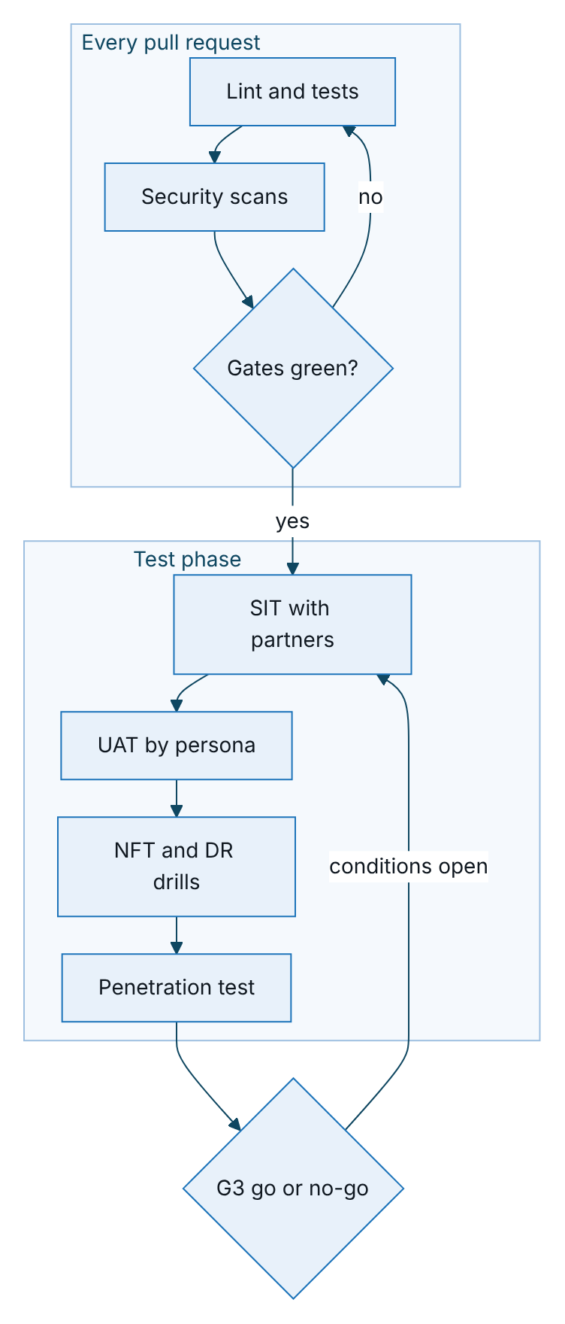
Figure 1 – Test approach, from automated gates on every change to the go-live decision

Unit tests
Unit tests cover the pure domain and shared modules: plate and phone normalisation, enrichment, scoring and next best action, the three rating methods, contact policy, the voice dialogue, rules evaluation, encryption, resilience, metrics and log redaction. They use the built-in node:test runner, consistent with the platform’s single runtime dependency (pg). Tests are deterministic: the clock, business date and random seed are injected, and there is no network access.

Integration tests
Integration tests wire the application services through createContainer(config) with the in-memory store and sandbox gateways. Typical flows are ingest, rebuild, lead recompute and touchpoints; purchase, issuance, confirmation and cross-sell; rule approval and cache refresh; and core rating, fallback, re-rate and catalogue sync. Faults are injected by replacing a gateway port, for example a wallet that fails or a TASCO core that times out.

API and contract tests
API tests call every route in the route table over real HTTP: 97 routes in release 1.0.0 (6 public, 76 staff, 11 customer, 4 partner). The OpenAPI document is generated from the same table, so contract tests check that it lists every route, declares security per audience, requires Idempotency-Key on both order routes and rejects unknown body properties. CI regenerates the document and fails if it differs from the committed copy.
The authorisation matrix calls every route with each of 15 principals (13 staff roles, a customer and a partner) and checks for 2xx, 401 or 403. Negative tests cover 400, 404, 405, 409, 413, 415, 422, 423 and 429.

Functional acceptance tests
There is one automated test for every Given/When/Then scenario in TGP-BUS-04 User Stories and Acceptance Criteria, named US-xxx · scenario, running against the real API with the in-memory store. The suite has 124 scenarios: 121 automated and 3 recorded as to-do because they are manual or roadmap items (US-055 fleet dashboard, US-076 language toggle and US-077 physical QR scan, the last two verified in UAT). Each scenario is a row of the workbook sheet Functional Test Cases.

System integration testing
SIT runs in the SIT environment (PostgreSQL, demo mode off, production adapters pointing at partner UAT endpoints). Exit needs all P1 SIT cases passed and interface defects closed or waived by both parties.
Interface | Counterparty environment | Key scenarios | Prerequisite
Core rating and catalogue | TASCO core UAT | Quote each product; validity and quote reference; catalogue fetch and sync proposal; fail-closed and fallback behaviour (TC-180) | Confirmed interface specification; OAuth client credentials
Policy issuance and cancellation | TASCO core UAT | Issue TNDS car and motorbike, physical damage cover after inspection, personal accident cover per seat; multi-line failure and compensation (TC-153) | Production issuance adapter; product mapping signed off
Wallet debit and refund | VETC wallet UAT | Idempotent debit; timeout then retry; refund after issuance failure; insufficient balance (TC-152) | Wallet adapter; funded test wallets
Customer sign-on | VETC identity UAT | Token exchange; expired and foreign-audience tokens (TC-151) | Production token verification
Messaging | Zalo ZNS, SMS brandname, VETC app push | Approved templates and parameters; diacritics and length; deep link opens the renewal (TC-149, TC-150) | Zalo template approval; brandname registration; app build
Voice | Voice vendor test trunk | Real speech into the dialogue; plate-first check; opt-out; transfer (TC-154) | Vendor contract and test numbers
Events and extracts | VETC event feed, VETC and TASCO extracts | Tag activation and inspection events; batches of 2,000 records or fewer; lineage; settlement comparison (TC-155) | Data-sharing agreement; masking

User acceptance testing
Business users run scenarios by persona: campaign manager, telesales agent and supervisor, rule author and approver, compliance officer, data steward, claims handler, partner manager and developer, customer, executive, auditor, administrator and support engineer. The plan, scenarios and sign-off sheet are in TGP-QA-04 User Acceptance Test Plan.

Non-functional testing
Type | Objective | Approach | Reference
Load | Meet the p95 targets at the design point | npm run test:perf (p50, p95, p99, requests per second); k6 for distributed load | TGP-QA-03, PERF-S1 to S6
Volume | Pilot cohort, then 6 million profiles | Synthetic generator in the PERF environment | PERF-S7 to S9
Stress and soak | Graceful degradation; no leaks over 12 to 24 hours | Ramp to 2× the design point; 60 % load for 12 hours | PERF-S10, S11
Security | No open critical or high findings | Static, dependency, secret, container and dynamic scans; abuse-case suite; penetration test | Security testing below
Resilience | Breakers, outbox, database failover, pod loss | Fault injection | Resilience testing below
DR | Recovery within the targets | PITR restore; failover drills | TGP-OPS-03, DR-T1 to DR-T7
Accessibility | WCAG 2.2 AA | Automated scan plus screen reader and keyboard passes | TC-144 to TC-146
Usability | Key tasks completed by agents and customers | Moderated sessions | TGP-UX-04 Usability Testing Plan

Security testing
Control | Tool or test | Gate
Static analysis | CodeQL (security-extended) | No new high or critical alerts
Lint | ESLint 9 | Zero errors
Dependencies | npm run audit (production dependencies) | No high or critical
SBOM | CycloneDX | Attached to every tagged build
Secrets | gitleaks over the full history | Zero findings
Container | Trivy image scan | No high or critical without a dated waiver
Dynamic scan | ZAP baseline on every push (report only); authenticated scan before G3 | No high-risk alert at release
Abuse cases | test/security | All pass
Penetration test | Independent vendor, grey-box, OWASP ASVS Level 2 scope, during the test phase | No open critical or high at G3; mediums with a dated plan

Control in code | Abuse cases
Token checks: algorithm, signature, expiry, audience, tokens issued before a password, role or status change | TC-011, TC-013 to TC-016
Lockout after 5 failures across password and code for 15 minutes; code replay refused | TC-005, TC-006, TC-020
Sign-in limit 10 per minute per IP; global limit 300 per minute per IP | TC-121, TC-122
Body limit 1 MiB; JSON only; static path traversal guard; unknown properties refused | TC-117 to TC-120
Parameterised SQL and column allow-list | TC-123, TC-124
Ownership checks on customer and partner quotes | TC-071, TC-081
Maker-checker | TC-090, TC-091
Field encryption at rest and log redaction | TC-108, TC-109
No personal data in core rating requests | TC-170, TC-177

Resilience testing
Fault | Injection | Expected behaviour
VETC wallet slow or down | Port with delay over 5 s or errors | 5 s timeout, 2 retries with backoff, circuit vetc-wallet opens after 5 failed calls for 30 s; order payment_failed; 503 UPSTREAM_UNAVAILABLE
TASCO core rating slow or down | Port times out or circuit opens | Circuit tasco-core-rating opens after 5 failed calls. core mode: 503 and no quote. core_with_fallback: indicative quote that cannot be paid until re-rated (TC-167 to TC-169)
TASCO core issuance fails after payment | Issuance port fails | Issued lines cancelled, full refund through the wallet breaker; order issuance_failed_refunded, or compensation_failed for manual action (TC-080)
TASCO core catalogue unavailable | Catalogue port fails | Sync job recorded as failed; active products unchanged (TC-173)
Zalo ZNS or SMS down | Notification port fails | Message failed; next channel in the step tried
Voice vendor down | Telephony port fails | Circuit voice-ai (30 s timeout, no retries); voice steps fail, other steps continue
Event handler failure | Subscriber fails | Event retried; after 5 attempts dead_letter
Process crash during relay | Kill the process | PostgreSQL re-claims events stuck in processing after 5 minutes; completed handlers skipped
Database failover | Managed failover | Readiness 503 during the switch; pool reconnects; no 500 storm
Pod termination | Delete a pod under load | Readiness false, server closes within 25 s, no failed in-flight requests
Several replicas relaying | 3 replicas | Row locking prevents double claims; handlers idempotent

Accessibility and localisation
Every staff console page, the customer app and the certificate verification page are scanned with axe-core in both themes and both languages, with zero serious or critical violations allowed. Manual passes cover keyboard-only use, NVDA, VoiceOver and TalkBack, 24 × 24 pixel touch targets, accessible authentication (paste and password managers allowed) and announced status messages.
Customer-facing text is Vietnamese first, with English for staff review. Tests check that placeholders resolve, dates print as dd/mm/yyyy, amounts print with đ and SMS length stays within the agreed segments. The voice bot matches both accented and unaccented speech.

Compliance testing
Control | Test focus | Cases
Copy guard: no discount, rebate or cashback wording for price-regulated products | Banned phrases rejected in drafts, with and without diacritics and with spacing tricks; blocked at send time | TC-060, TC-061, TC-095
Contact window 08:00 to 20:00 for marketing | Boundary values 07:59, 08:00, 19:59, 20:00 | TC-050 to TC-052
Consent and do-not-contact | No marketing without consent; no calls without call consent; DNC suppresses everything | TC-053 to TC-055
Frequency caps | 1 per day and 3 per week for marketing; 2 calls per week; service messages exempt | TC-056 to TC-058
Maker-checker and separation of duties | Self-approval refused; conflicting roles refused; restricted rule kinds need a compliance officer | TC-027, TC-090 to TC-092
Commission caps | Drafts above the statutory cap refused; runtime capping | TC-084, TC-085
Personal data minimisation | Masking by permission; certificate check without name; no identity in rating requests | TC-031, TC-074, TC-170
Benefits pending legal review | Loyalty points never shown to customers | TC-041
Data subject rights | Export complete; erasure refused while a policy is active | TC-105 to TC-107
Voice bot disclosure and plate-first | Bot never reads the full plate; discloses automation; opt-out honoured | TC-064 to TC-069
Staff never take payment | No staff route debits a wallet; assisted sales send the quote to the customer | TC-156, TC-157
No time override in production | Contact window always on the real clock outside demo mode | TC-162
Price bound by TASCO core | Indicative prices cannot be paid; core answers never overridden | TC-166, TC-167
Regulatory interpretations in these rules are to be confirmed by TASCO legal before go-live.

Data quality, reconciliation and migration
The golden record follows survivorship by source trust, expiry inference by evidence weight and protection of customer-declared, voice-bot and TASCO-issued facts. Data quality issues are raised once and re-raised only after resolution. After each ingest batch, records equal upserted source records, rejected equals invalid plates and profiles touched equals distinct valid plates.
Reconciliation flags completed orders without a payment reference or policy, orders pending for more than an hour, and compensation_failed and payment_failed orders. In SIT it is also compared with VETC settlement files and TASCO issuance reports; that comparison is manual until a settlement adapter exists (KI-18).
Migrations are applied in a transaction per file under an advisory lock. Tests cover a fresh database, a re-run (no-op), schema parity with schema.js, upgrade at production-like volume, and the objects created by 002_integrity_hardening.sql. Applied migration files are never edited; DBA review enforces this and a CI check is recommended. The initial load of the pilot cohort is reconciled against the source extracts (TC-112).

Automation and regression

Automated test layers
The automated suites are layered from fast domain checks up to user-story scenarios against the running API. The numbers below are the test counts in the 8 October 2026 run (255 tests).
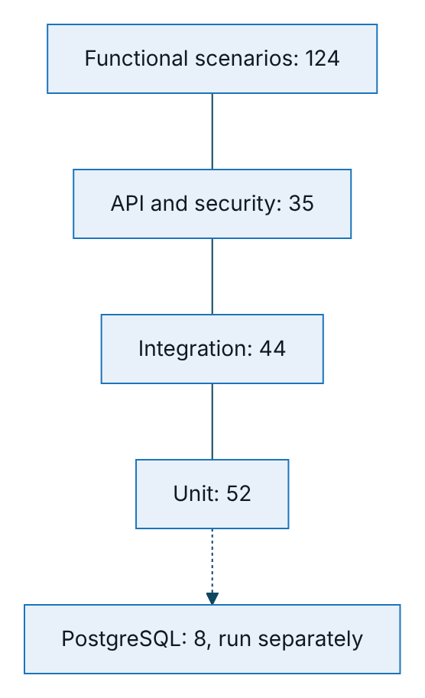
Figure 2 – Automated test layers and their test counts in the 8 October 2026 run
Folder | Content
test/unit | identity, jsonLogic, platform, rulesDomain, stores, tascoCoreRatingClient, voicebot
test/integration | coreRating, governance, governanceStudio, journeys, reviewFixes, sales
test/api | HTTP, contract and authorisation matrix; console and sales workflows; customer hosts and vehicle confirmation
test/security | Abuse cases and hardening regressions
test/functional | One test per user-story scenario, in three epic files
test/pg | PostgreSQL adapter (needs TEST_DATABASE_URL)
test/perf | load.js, a dependency-free load generator

CI gates
Gate | Command or tool | Blocks a pull request | Blocks a release tag
Lint | npm run lint | Yes | Yes
Tests with coverage | npm run test:coverage: lines and functions ≥ 80 %, branches ≥ 70 % | Yes | Yes
OpenAPI contract | Regenerate and diff the committed document | Yes | Yes
PostgreSQL tests | npm run test:pg against PostgreSQL 16 | Yes | Yes
Performance smoke | npm run test:perf (15 s, 25 concurrent): p95 ≤ 300 ms, errors ≤ 1 % | Yes | Yes
CodeQL, dependency audit, gitleaks | As in Security testing | Yes | Yes
Container scan | Trivy | Yes (high or critical) | Yes
SBOM | CycloneDX | No | Yes (artefact)
Dynamic scan | ZAP baseline | No (report only) | Yes (no high)

Regression
Every pull request runs the full automated suite; it takes minutes because the in-memory store needs no infrastructure. Release candidates add a SIT smoke (wallet debit and refund, core rating and issuance, ZNS send, sign-on) and manual regression of the changed area. Every fixed Sev 1 or Sev 2 defect gets an automated regression test that names the defect.
Business rule changes go through maker-checker, not a code release. The rules studio’s validation and simulation are the regression tools: a change to scoring, next best action, journeys or benefits includes a simulation on the reference profiles in TGP-QA-04 as approval evidence. Product changes proposed by the catalogue sync follow the same approval.

Environments
Environment | Purpose | Store and data | Demo mode | Integrations
Local and CI | Development and automated tests | In-memory (PostgreSQL for test:pg); synthetic | Per test | Sandbox
Development | Feature integration | PostgreSQL; synthetic, 2,500 to 50,000 records | On | Sandbox
Hosted UAT (Railway) | Walkthroughs, training and early feedback at https://tasco-growth-api-uat.up.railway.app | PostgreSQL; synthetic; demo accounts kept usable | On (NODE_ENV=uat) | Sandbox
SIT | Integration with partners | PostgreSQL; synthetic and partner test identities | Off | Production adapters to partner UAT
UAT | Business acceptance | PostgreSQL; synthetic and masked samples, no production personal data | Off (named accounts) | Production adapters to partner UAT
PERF | Load, volume, soak, stress | PostgreSQL sized as production; synthetic up to 6 million profiles | Off | Sandbox with injected latency
PREPROD | Release rehearsal and DR drills | PostgreSQL with PITR; synthetic | Off | Partner UAT
Production | Live service | PostgreSQL HA with PITR; real data | Off | Production adapters
In production mode the process refuses to start without JWT_SECRET, BLIND_INDEX_KEY, DATA_KEYS and DATABASE_URL, or with demo mode on. It also refuses local rating unless ALLOW_LOCAL_RATING is set, and requires an https core URL with client credentials when core rating is configured (TC-159, TC-176). The production configuration ships with RATING_SOURCE=core.

Test data management
Synthetic data comes first. The generator reproduces the real data problems: about 1 in 10 records with a verified policy, dirty plates and phones, duplicates across sources and partner-owned policies. It is deterministic for a given seed and sized with SEED_RECORDS (2,500 by default, 6 million in batches for volume tests).
No production personal data is used outside production. SIT and UAT use synthetic profiles and partner test identities (test wallets, test SIMs, test Zalo accounts). Extracts used for data profiling in discovery are masked.
SIM_TODAY pins the business date so journey offsets and the 24-hour quote validity are reproducible. Simulated times on journey and voice campaign runs are honoured only in demo mode.
The demo users (14 staff users covering 13 roles, with MFA for administrator, approver, compliance and data steward) exist only where demo mode is on, and the seed job refuses to run otherwise. Locally the demo password is Tasco@Demo2026!. The hosted UAT uses a separate password, issued in the UAT access workbook and never written in documents; it also publishes authenticator keys for the MFA demo users and resets the demo accounts at start-up.

Entry and exit criteria
Level | Entry | Exit
Unit, integration, API | Story in progress with acceptance criteria | All pass; coverage gate met; no lint errors
SIT | Build complete (G2, 08/01/2027); production adapters in SIT; partner endpoints and credentials available; interface agreements signed | All P1 and at least 95 % of P2 SIT cases passed; no open Sev 1 or 2 interface defects; reconciliation proven end to end
UAT | SIT exit met; environment loaded; users trained | TGP-QA-04 exit criteria and signed sign-off sheet
NFT | Feature-complete build in PERF; monitoring in place | Targets in TGP-QA-03 met; soak shows no leak; DR drill within targets
Security | Feature-complete build | No open critical or high findings; mediums with a dated plan
Go-live (G3) | All of the above | TGP-OPS-04 Production Readiness Checklist complete or waived by the Steering Committee

Defect management

Severity
Severity | Definition | Examples | Fix expectation in test phases
Sev 1, critical | Data loss, security or regulatory breach, money taken without cover, or a core flow down with no workaround | Customer charged with no policy or refund; personal data exposed; banned wording sent; DNC customer contacted; indicative price paid; audit chain broken | Before the next build; blocks the gate
Sev 2, high | Major function broken with a costly workaround; compliance risk | A cohort skipped by journeys; wrong partner commission; opt-out not saved; lockout not enforced | Before gate exit
Sev 3, medium | Function impaired with a reasonable workaround | Wrong lead filter; dashboard count off; 500 instead of 400 | Fixed or planned before go-live; can be waived
Sev 4, low | Cosmetic or minor | Label typo | Backlog
The Product Owner sets business priority (P1 to P4) separately.

Workflow
Defects move through daily triage by the QA Lead, Product Owner and Tech Lead; a defect is closed only after a passing retest and, for Sev 1 and 2, an automated regression test.
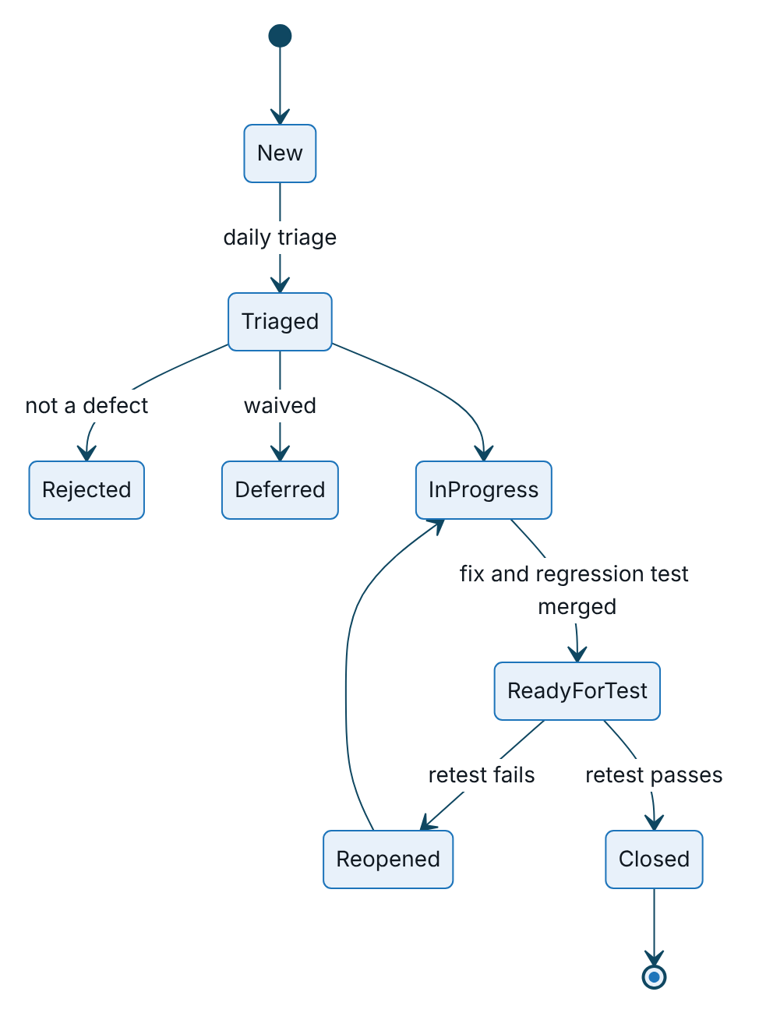
Figure 3 – Defect workflow, from triage to closure after a passing retest
Sev 3 and 4 deferrals are approved by the Product Owner; Sev 1 and 2 deferrals by the Steering Committee. Each defect records the environment, build, X-Request-Id (returned in every response and error body), route, persona, steps, expected and actual results, severity and priority. Data defects carry the profile ID, never personal data.

Metrics
Metric | Target
Automated pass rate on main | 100 % (flaky tests quarantined within 24 hours)
Coverage (lines, functions, branches) | At least 80, 80 and 70 %
Requirements traced to tests | 100 % of MVP stories have at least one test
Defects found before production (30 days after go-live) | At least 90 %
Open Sev 1 or 2 at a gate | 0
Reopen rate | Under 10 %
Time to fix Sev 1 and Sev 2 in test phases | Under 1 day and under 3 days
SIT pass rate for P1 cases | 100 %
Serious or critical accessibility violations | 0

Roles and responsibilities
Role | Organisation | Responsibilities
QA Lead | iorta TechNXT | Owns this strategy and the catalogue; triage, reporting, gate evidence
Test engineers | iorta TechNXT | Automated suites, SIT execution, regression
Performance engineer | iorta TechNXT | Load, volume, soak, stress; capacity model
DevSecOps engineer | iorta TechNXT | CI security gates; penetration test coordination
SRE | iorta TechNXT, then TASCO IT | Resilience and DR tests; monitoring
Product Owner | TASCO Insurance | Acceptance criteria, defect priority, UAT coordination
Business testers | TASCO Insurance and VETC | UAT execution and sign-off
Compliance officer | TASCO Insurance | Sign-off of copy guard, contact policy, consent, scripts and benefits
Data steward | TASCO Insurance | Data quality acceptance; reconciliation sign-off
Partner IT | TASCO core IT, VETC IT, Zalo | SIT endpoints, test data, interface defect fixes
Penetration tester | Independent vendor | Penetration test and report

Current results
The latest full run was on 7 October 2026 on release 1.0.0 (Node.js 22; PostgreSQL 16 for test/pg; in-memory store for the other suites).
Measure | Result | Gate
Automated tests (npm test) | 255 tests: 252 passed, 0 failed, 3 to-do (the manual and roadmap scenarios) | 0 failed
PostgreSQL suite | 8 tests, all passed: migrations, encryption at rest, injection resistance, audit immutability, one active rule version per kind, row-locked outbox claims and an end-to-end sale | All pass
Functional scenarios | 124: 121 automated and passing, 3 manual or roadmap | All automated pass
Coverage (lines, branches, functions) | 99.41 %, 88.25 %, 97.12 % | 80 %, 70 %, 80 %
Lint | 0 errors | 0 errors
Load smoke (one process, 25 concurrent, 15 s) | 337 requests per second, p95 103 ms, 0 errors | p95 ≤ 300 ms, errors ≤ 1 %
Catalogue cases in the workbook | 184: 157 Pass, 23 Not Run, 4 Blocked | —
The Not Run cases are the SIT, UAT, DR, accessibility and at-scale performance cases, which belong to later phases. The four Blocked cases depend on open known issues: TC-017 (KI-07), TC-029 (KI-10), TC-114 (KI-13) and TC-155 (KI-18). The core rating cases TC-165 to TC-179 run in the suites above and passed; they are added to the workbook at its next regeneration.

Known issues
These issues were found while the tests were derived and are logged as defects with a proposed severity. IDs are stable and are referenced by test cases, runbooks and the readiness checklist. The QA Lead re-verifies the status at every release. Of 33 issues, 16 are open (three of them partly fixed) and 17 are fixed; the fixed items are listed in the Appendix.
ID | Sev | Area | Finding | Recommendation
KI-03 | 3 | Events | Partly fixed: stuck events are re-claimed after 5 minutes, but dead-letter events have no replay tool | Ops job to requeue dead letters; interim SQL in RB-06
KI-04 | 2 | Performance | Several handlers drain the global event backlog inline, so one request’s latency depends on everyone’s events | Drain only the request’s own events or rely on the relay; measured by PERF-S5
KI-07 | 3 | Security | Sign-out and rate limits are per replica, so limits multiply and a revoked token stays valid elsewhere until expiry (30 minutes) | Shared cache or gateway limits; short token lifetime
KI-08 | 4 | Security | Partly fixed: renewal links expire, but are keyed from JWT_SECRET, so rotating it invalidates every link sent | Separate link key
KI-10 | 3 | Access control | Partly fixed: regional checks do not yet cover voice sessions, policy lists and the claims list | Apply the access check consistently
KI-12 | 3 | Performance | Audit verification loads the whole log; several jobs page with OFFSET, which degrades at 6 million rows | Verification checkpoints; keyset pagination; SQL aggregates
KI-13 | 2 | Compliance | Retention deletes only source records and voice sessions; profile anonymisation and archival of messages, orders and certificates have no job | Build the archival job, or a legal waiver before go-live
KI-16 | 4 | API | Ingest accepts 5,000 records but the body limit is 1 MiB | Batches of 2,000 or fewer, or a per-route limit
KI-17 | 4 | Observability | Metrics have no type lines or gauges for circuit state, outbox backlog or pool; counters reset on restart | Add gauges; alert rules use rates
KI-18 | 2 | Sales | A wallet debit that times out on our side but is captured by VETC leaves the order payment_failed with no refund; no settlement adapter | Daily settlement reconciliation; reconciliation flags every payment_failed order (RB-11)
KI-19 | 3 | Security operations | No re-encryption job after a data key rotation; the blind-index key cannot be rotated without a rebuild | Re-encrypt and re-index job (SOP-01)
KI-20 | 4 | Sales | Two concurrent purchases with the same key: the second gets 409 instead of a replay. No double charge is possible | Return the stored order on conflict
KI-21 | 4 | Rules | The commission validator checks caps only where the rule names the product literally; runtime still caps | Validate every product and partner type
KI-22 | 4 | Security | The request body is read before authentication | Authenticate first on non-public routes
KI-23 | 4 | Security | Customers cannot revoke their own one-hour tokens | Customer sign-out, or a shorter lifetime with refresh
KI-24 | 4 | Roll-out | No fact supports a percentage cohort, so “10 % of the base” needs a code change | Add a stable cohort bucket fact

Appendix

Fixed known issues
ID | Sev | Area | Fix | Regression
KI-01 | 1 | Security | Seed job refuses to run unless demo mode is on; no seed job in the Kubernetes manifests | TC-134
KI-02 | 1 | Sales | Saga compensation: issued lines cancelled, full refund through the breaker, compensation_failed flagged by reconciliation | TC-080
KI-05 | 2 | Journeys | Journey runs page through all due touchpoints; window-blocked touchpoints are deferred, not skipped | TC-050
KI-06 | — | Security | MFA step checks status and lock, counts failures across both factors, refuses code replay | TC-020
KI-09 | 1 | Compliance | Voice campaign checks consent, DNC, window and caps for each call and records the contact | TC-135
KI-11 | — | API | Malformed path encoding returns 400 | TC-129
KI-14 | 4 | Security | /metrics requires a bearer token when METRICS_TOKEN is set | TC-132
KI-15 | — | Front end | Staff console, customer app and certificate verification pages present | Smoke test
KI-25 | 2 | Voice bot | Spoken plates with Vietnamese tens and motorbike plates parse | TC-065
KI-26 | 3 | Compliance | Copy guard also matches with spaces, dots, hyphens and underscores removed | TC-061
KI-27 | 3 | Identity operations | Administrator unlock and MFA reset endpoint, audited, never reveals the seed | SOP-08
KI-28 | 1 | Configuration | Production refuses to start without DATABASE_URL | TC-159
KI-29 | — | Privacy | Erasure also clears handoffs, claims text and voice signals and revokes sessions | TC-107
KI-30 | — | Deployment | Migrations take an advisory lock | test/pg
KI-31 | 3 | Sales | Replaying a failed attempt’s key returns 409; a new key succeeds | TC-160
KI-32 | 4 | Access control | Region checked before a quote is marked as sent | TC-158
KI-33 | 2 | Compliance | Simulated times honoured only in demo mode | TC-162

Sign-Off
Serial Number | Description | Owner | Status
1 | TASCO core UAT endpoints, interface specification and test credentials available for SIT by 11/01/2027 | TASCO IT Architecture | Open
2 | VETC wallet, VETC identity and Zalo test accounts available for SIT by 11/01/2027 | VETC IT and TASCO Marketing | Open
3 | Independent penetration test vendor appointed for the test phase | TASCO CISO | Open
4 | Decision on open Sev 2 known issues KI-04, KI-13 and KI-18 (fix or dated waiver) before G3 | TASCO Programme Sponsor | Open
5 | Retention of profiles, messages, orders and certificates without an archival job (KI-13) to be confirmed by TASCO legal | TASCO Legal | Open

Sign Off Date | Signature | Approved By | Department & Project Role
 |  | TASCO Insurance | Programme Sponsor
 |  | TASCO Insurance | IT Quality Assurance
 |  | iorta TechNXT | Quality Engineering



